

Practices for Secure Software Report

Sarah Copeland

Table of Contents
Document Revision History 3
Client 3
Instructions 3
Developer 4
1. Algorithm Cipher 4
2. Certificate Generation 4
3. Deploy Cipher 4
4. Secure Communications 4
5. Secondary Testing 4
6. Functional Testing 4
7. Summary 4
8. Industry Standard Best Practices 4

Document Revision History

Version | Date | Author | Comments
1.0 | [Date] | [Your Name]

Client



Instructions

Submit this completed practices for secure software report. Replace the bracketed text with the relevant information. You must document your process for writing secure communications and refactoring code that complies with software security testing protocols.

- Respond to the steps outlined below and include your findings.
- Respond using your own words. You may also choose to include images or supporting materials. If you include them, make certain to insert them in all the relevant locations in the document.
- Refer to the Project Two Guidelines and Rubric for more detailed instructions about each section of the template.

Developer
Sarah Copeland

Algorithm Cipher

For this project, I implemented the SHA-256 hashing algorithm to support checksum verification when data is transferred through Artemis Financial’s web application. SHA-256 creates a 256-bit output that acts as a digital fingerprint of the original data. This allows the system to confirm that information has not been changed during transmission.
Hashing is different from encryption because it is designed to be one-way. Instead of protecting confidentiality, it protects integrity. Even a small change in the input produces a completely different hash value, making it a reliable way to detect tampering.
Secure communication is handled through HTTPS, which combines asymmetric and symmetric encryption. Asymmetric encryption is used during the initial handshake to establish trust, and symmetric encryption is then used for efficient data transfer. Random session values ensure secure communication and help prevent replay attacks. SHA-256 remains a modern industry standard and is considered far more secure than older algorithms like MD5 or SHA-1.

Certificate Generation
Insert a screenshot below of the CER file.

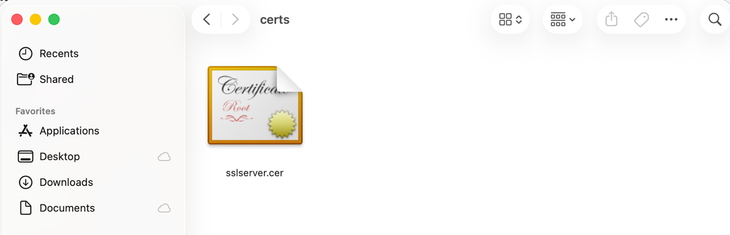

Deploy Cipher
Insert a screenshot below of the checksum verification.

Secure Communications
Insert a screenshot below of the web browser that shows a secure webpage.

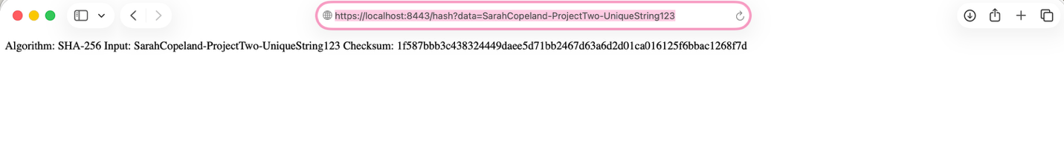

Secondary Testing

After refactoring the application, I performed a secondary static analysis using the OWASP dependency-check Maven plug-in. The tool ran successfully and generated an HTML report, which I reviewed to confirm that the changes I introduced did not create any new dependency-related vulnerabilities. I captured screenshots of both the execution and the generated report for documentation.

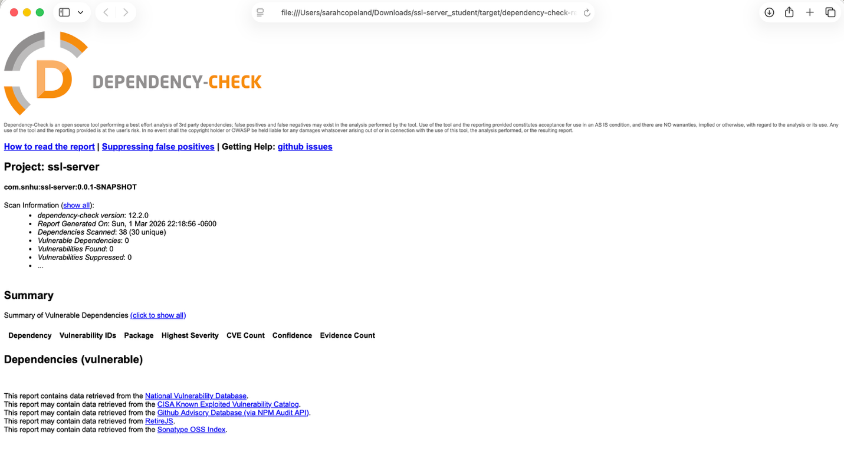

Functional Testing
I manually reviewed the updated code to identify any syntax, logic, or security concerns. The application compiled and ran successfully, and I verified that the checksum endpoint behaved as expected. This confirmed that the new security features were integrated without introducing runtime issues.

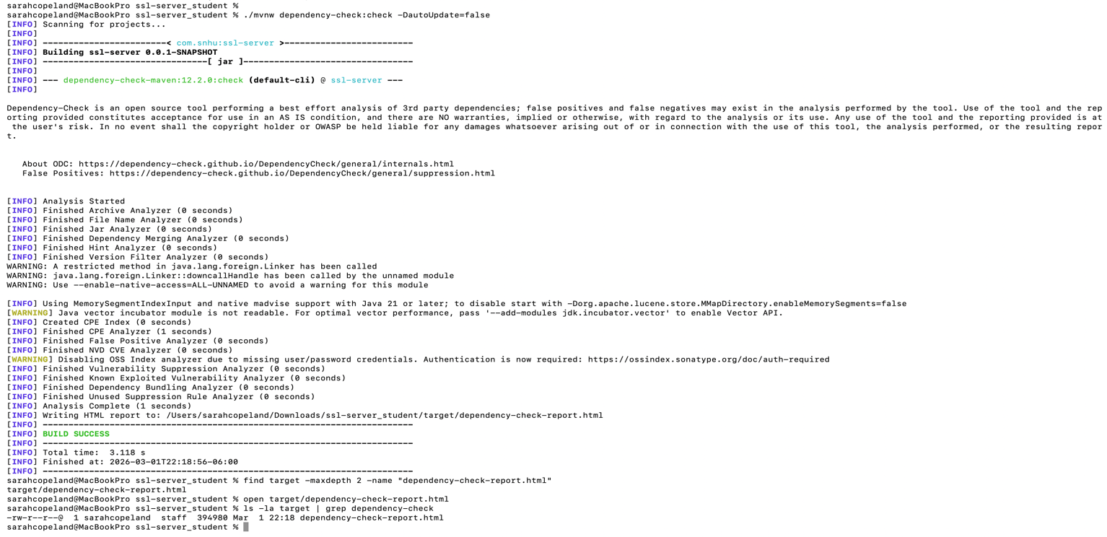

Summary

In this project, I refactored the application to strengthen its security by adding checksum verification and enabling HTTPS communication. Following the vulnerability assessment process, I focused on improving cryptographic handling, secure communication between client and server, and overall code reliability. The SHA-256 endpoint allows the application to verify data integrity, while HTTPS protects information during transmission. I also ran static dependency analysis to confirm that the added functionality did not introduce new vulnerabilities. Together, these changes add another layer of protection by helping ensure that transferred data remains both secure and unchanged.

Industry Standard Best Practices

To align with industry best practices, I relied on established security standards rather than creating custom implementations. HTTPS was used to secure data in transit, and SHA-256 was used to validate data integrity. Using trusted encryption protocols helps protect sensitive financial data from interception or manipulation. Running static analysis on project dependencies also supports long-term security by identifying known vulnerabilities early. Applying these practices improves the overall security of Artemis Financial’s application and helps reduce potential risk to both the company and its clients.

